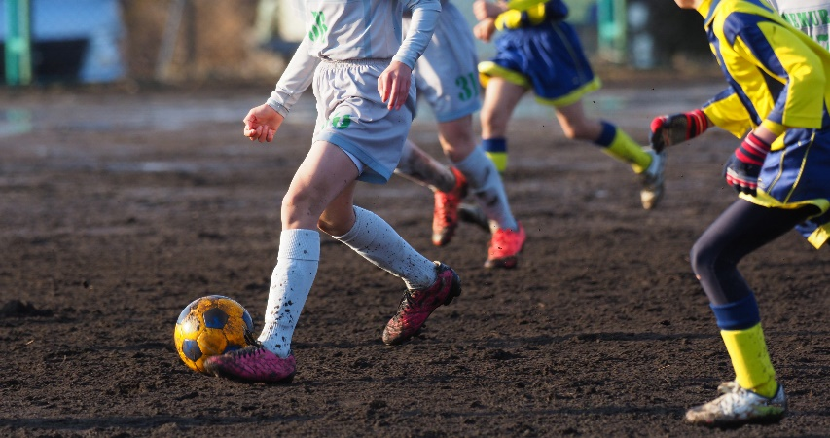  National LADO Network |  |   June 2024
Save the date! National LADO conference - Monday 7th October 2024.
We are pleased to announce that the next National LADO conference will be face-to-face on Monday 7th October at the Old Trafford conference center. Further details to follow. The venue has excellent transport links and a free car park. It is an opportunity to meet lots of LADO's and challenge and support each other as it can be a very isolating role.
In the context of Social Work, LADO is relatively new role and we continue to struggle to get specific and bespoke training because the role is so varied. Therefore, we wanted to regularly pull together some suggested reading from across the worldwide web to assist you with your practice and also to support people to reach their requirements for SW England registration.

Working with Faith Groups  The NLN are looking to set up a Task & Finish group about sharing good practice regarding working with faith groups. If you want to be part of this group, please email Alison Small - Alison.Small@bracknell-forest.gov.uk  Why not join the NLN training subgroup?  We meet once a month to design the newsletter and plan training and conferences for the NLN. Any LADO is welcome. Meetings are held via MS Teams so should not incur any cost! Email - Colette.morris@oldham.gov.uk for an invite to the group. |  | WHats New?
Resource;
If you have any cases connected to stalking or harassment, then check out the following websites for information, guidance, resources and links to training.
Suzy Lamplugh Trust - www.suzylamplugh.org
Alice Ruggles Trust - www.alicerugglestrust.org

LADO & Sports - Update from Andrea Garcia-Sangil - lead LADO for Sports, provides an update for LADOs around her recent work with the sport community.
I wanted to provide an update to my fellow LADOs in respect to our ongoing work engaging sporting organisations and bring everyone into the fold.
We have long been aware that we don’t see many referrals from sports, and it is something we have mentioned in a number of the National LADO meetings over the years. I think many of us thought this might change after the Sheldon Inquiry in 2021 (into child abuse in football) and the Whyte Inquiry in 2022 (into child abuse within gymnastics). During the pandemic there appeared to be a lot of unveiling in respect to abuse perpetrated by sports coaches, and of course we saw these roles being recognised as holding a position of trust when changes to Law were made in June 2022. It was very clear that abuse was occurring within sports, and therefore we knew that allegations must exist, though we were not receiving a number of referrals which would indicate that the LADO was even being considered by National Governing Bodies (NGB’s).
Given that as a LADO I was not seeing the expected changes, in April 2023 I contacted the Child Protection in Sport Unit (CPSU). The CPSU are part of the NSPCC and were founded in 2001 to work with UK sports councils, governing bodies and other organisations to help them minimise the risk of child abuse during sporting activities. Around this time, I asked for some volunteers to be part of a small ‘task team’ to work on these issues with the CPSU. We have since had a few meetings and there is still a lot of work to do in the future so if you wish to be included, please let me know.
Having started to pick at the ‘sports scab’ it became apparent that the problems were bigger than anticipated. So of course I did what all self-respecting LADOs would do, and asked Steve Hall to help me.

We became aware that in 2022 Sport England obtained funding from the National Lottery to create a “Safeguarding Case Management Programme” which would support investigations into safeguarding concerns within sports. This would involve allegations against adults. Essentially, an NGB could contact a company called Sport Resolutions to ask that they appoint an investigator to complete an investigation on the NGB’s behalf. Lime Wire are responsible for quality assuring this process. At no point was a LADO consulted, nor were they written into any procedures. We were effectively forgotten! You can read about this programme using this link and scrolling down to the bottom of the page. Ironically, one of the things they do is “free initial advice on safeguarding cases” – insert side eye.
https://www.sportengland.org/guidance-and-support/safeguarding
Sport England state that “The programme supports but doesn't replace the safeguarding responsibilities of NGB’s…”.
For transparency, I am an independent investigator myself for Sport Resolutions and have been since 2022. It was brought to my attention by an NGB that my reports are very different than others because they included an assessment on any risk identified as well as recommendations on how to manage this. I assumed that all of the investigations via Sport Resolutions were being completed in this way until I started to review some which presented as fact finding enquiries only.
Therefore, we started to discuss reports produced by Sport Resolutions, especially ones caught in the LADO process. We identified that the reports were not fit for purpose and this was because the NGB’s and Sport Resolutions were agreeing their own Terms of Reference outside of the LADO process. This meant that when LADOs were reconvening meetings to discuss an outcome and way forward, the quality of the information gathered was not thorough or sufficient. In these reports no assessment of risk was offered or recommendations on how the sport would manage the risk. Instead, there was a heavy focus on disciplinary and other punitive measures only.
I met with a Case Manager from Sport Resolutions to explain this and it was clear that they did not understand the role of the LADO or when and why our procedures needed to be considered. Steve and I met with Lime Culture too who were quite shocked and disappointed with our feedback. Lime Culture informed us that we should speak to Chartered Institute for the Management of Sport and Physical Activity (CIMSPA).
At this point we had raised our concerns with the CPSU, Sport Resolutions, Lime Culture and were now being passed to CIMSPA… no one seemed to know who we should really be speaking to!!
We have since met with CIMSPA who are working on bringing about consistency to safeguarding within sport. I also recently chaired a meeting with an NGB who advised they would not be sharing their report with LADO because their internal policies did not allow this. I explained that the investigation fell under the LADO process in which I retained oversight and therefore needed sight if their report in order to execute my QA function and be satisfied that we have come to a fair outcome. They remain resistant and so we need to challenge this stance.
We have got to the point where changes will be made, but as LADOs’ we do need to be unified in our approach and response to sports. Collectively we need to be on the same page.

Thank You | Thank you for reading and we hope this was useful.  If you find anything that you think should be included in the next edition, then please contact Colette.morris@oldham.gov.uk - Oldham LADO.

