LADONews
ISSUE
January
2025
01
Kinship Care – An article
Research and recent legal developments highlight the growing importance and complexity of kinship care. Kinship/connected person foster care: Vicarious liability update

Guidance on the LADO role
Is to be issued for consultation in 2025. Guidance on LADO role to be issued for consultation in 2025 - Community Care

Join the NLN Subgroup
We meet once a month to design the newsletter and plan training and conferences for the NLN. Any LADO is welcome. Meetings are held via TEAMS so should not incur any cost!
e-mail – Colette.morris@oldham.gov.uk for an invite to the group
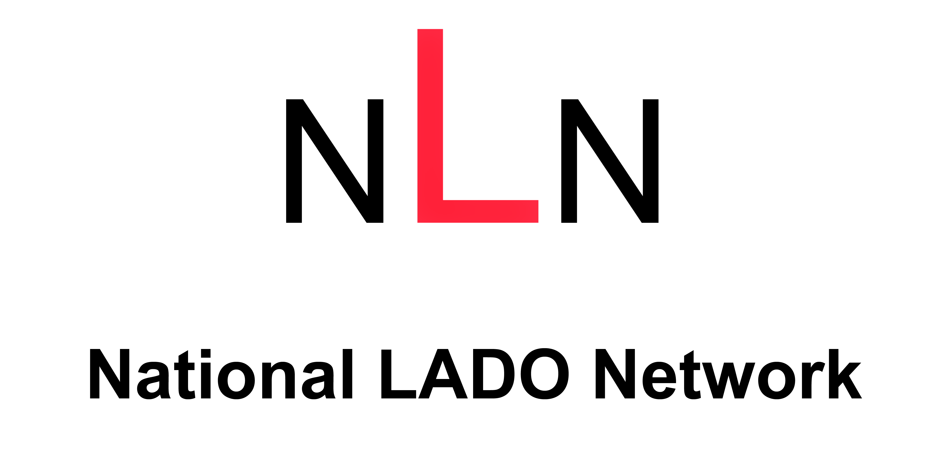
IICSA Inquiry
As the enquiry into CSE has been in the press recently. I include a link to the IICSA recommendations so that we can review. Recommendations | IICSA Independent Inquiry into Child Sexual Abuse
We are looking to run a number of webinars for LADO’s to allow national organisations to deliver an hours workshop to LADO’s. This will not replace a face-to-face conference but is designed to compliment the offer provided by the NLN. Any suggestions for this would be appreciated. We are in negotiations to have a speaker from the IRM (Independent Review Mechanism) in March to discuss their role. About us - Independent Review Mechanism - GOV.UK

Independent review into Church’s handling of Smyth case published
The independent review by Keith Makin into the Church of England’s handling of allegations of serious abuse by the late John Smyth has been published. independent-learning-lessons-review-john-smyth-qc-november-2024.pdf
this issue
Happy New Year!
Independent Review
IICSA Recommendations
Kinship Care
LADO Role/NLN Subgroup
Happy New Year!
In the context of Social Work, LADO is relatively new role and we continue to struggle to get specific and bespoke training because the role is so varied. Therefore, we wanted to regularly pull together some suggested reading from across the worldwide web to assist you with your practice and also to support people to reach their requirements for SW England registration.
A note on DISTRIBUTION. As you can imagine making sure that this newsletter reaches all the LADOs can be a difficult job. Therefore, it has been agreed that regional links will distribute the newsletter as they have a grip of LADO representatives within the region.
.

